New Hire Account Setup
Welcome to Abt!
If you need access to your email and timecard before your Abt computer is setup, please follow the instructions in sections 1 and 2.
Your local IT manager will help you configure your Abt Project computer (section 3). If you do not have an IT manager, please contact the IT Service Center (ITServiceCenter@abtassoc.com) and they will assist.
Contents
1. Setting Your Abt Password 1
2. Access From a Non-Abt Computer 4
A. Logging In 4
B. Accessing Oracle 6
C. Accessing Webmail 7
3. Access from your Abt Project Computer 8
A. Configuring Outlook 8
B. Enrolling Your Certificate 9
C. Accessing the Abt Global Intranet (AGI) 10
D. Accessing Oracle 11
E. Accessing Webmail 12

Setting Your Abt Password

Before you can use Abt systems you will need to set a password and enroll for Abt’s Remote Access Web page. This enrollment is a one-time set up of the security questions that will be used as part of the authentication process for remote access to Abt’s web applications.
- Go to http://enroll.abtassoc.com/ .
The Abt Self-Service Console web page appears.
- Enter your User ID (your Abt username).  Usernames are usually: Last Name + First Initial  Click OK. | 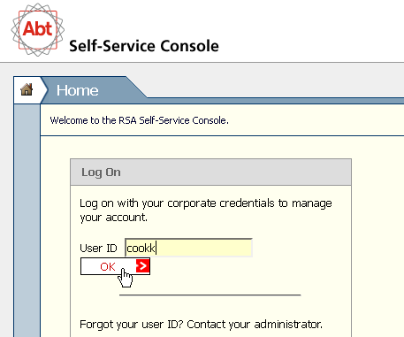
- Enter your password.  If this is your first time logging in, you should have received a temporary password.  Click Log On. | 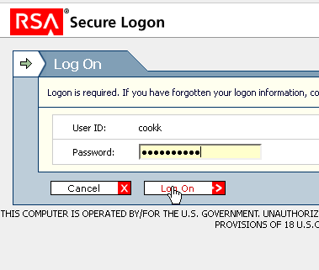
- You will be asked to change your password. Enter you current password in the first field. Enter your new password in the next two fields.  Click OK.  The password you select during the enrollment process will be valid for all Abt applications including Oracle and email.  Passwords must be:  - 8 or more characters  - at least one upper case and one lower case  - at least one number  - at least one special character !#$%^&*()  - (do not use @ or ~) | 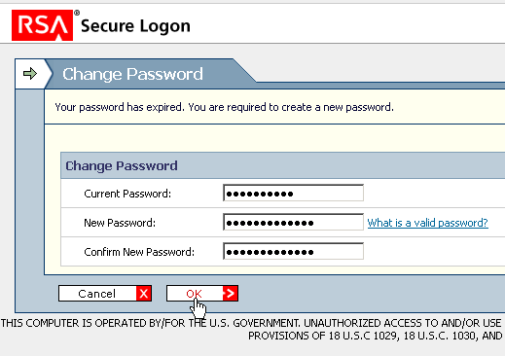
- The Set Up page appears prompting you to select and answer your security questions.  You may select your preferred language for your security questions. If you change your preferred language from the default of English, you will notice the text of the questions change at the same time.  Note: Security Questions / responses should be personal facts that do not change. e.g. Your paternal grandfather’s first name will never change. You cannot change the responses to your security questions like you change your password. These questions may also be the same as those that you use to secure your bank account. Please do not share this information with other staff.  Choose 7 security questions from the list of questions provided; and enter your answer for each question.  When finished, click the Submit Your Request button. | 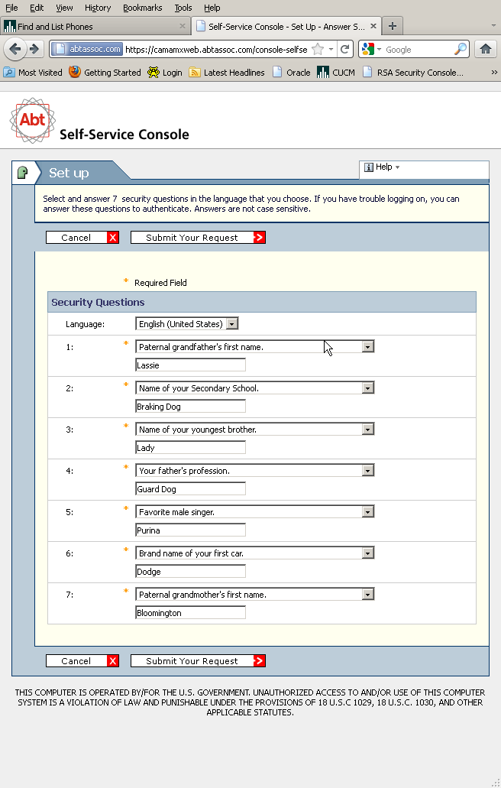
- The "My Account" summary screen appears with a notice that the "Security Questions successfully registered." At this point, the enrollment is complete. | 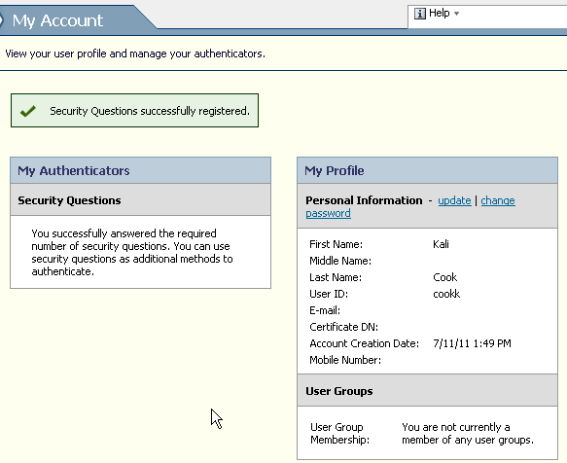
- Click the Log Off option in the upper right corner, and close your browser window. | 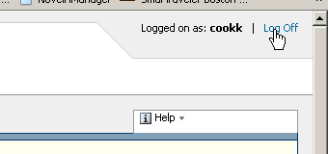
Now you will be able to use Abt’s web access page - http://abtremote.abtassoc.com/

Access From a Non-Abt Computer

Logging In

AMX - AuthenticationManager Express – provides strong remote access authentication to Abt Associates Web-based applications including Outlook Web Access (OWA), Oracle (for timecards) and the Abt Global Intranet (AGI).
Once you have enrolled and established your security questions, you will be able to remotely access Abt’s web applications using the Abtremote (http://abtremote.abtassoc.com) webpage.
If you have not yet enrolled, contact the IT Service Center to have your account enabled and then complete the enrollment process.
- Go to http://abtremote.abtassoc.com/
- Enter you User ID.  Click OK. |  |  | 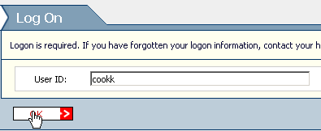
- Enter your Password.  Click Log On. |  |  | 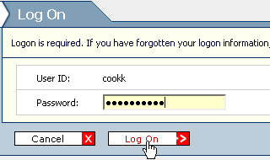
- You will be challenged to answer several security questions. Answer them using the same answers you did when you enrolled.  Note: Answers to security questions are not case sensitive.  Note: If you forget the answers to your security questions, or want to change them, contact the IT Service Center.  Note: If you have logged into Abt’s Remote Access page on this computer before you may not be presented with security questions.  Click the Continue button. |  |  |  | 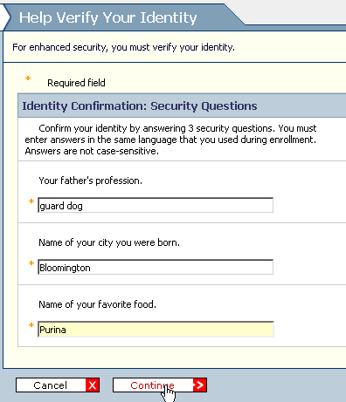
- You will be asked if this is a private computer you intend to use again, or a public computer.  Respond to “Remember this computer”:  * Choose Yes, I plan to use this computer in the future option ONLY if you are using your computer: Abt Laptop; home computer, etc.  * Choose No, this is a public computer or one I do not use often if it is a computer you do not control access to: Friend’s computer, Airport Kiosk, touch down station.  Click Continue. |  | 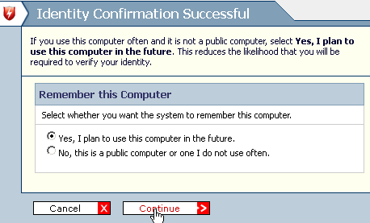
- You may be prompted to run or allow certain applications. Click ‘Allow’ or ‘Run’. |  | 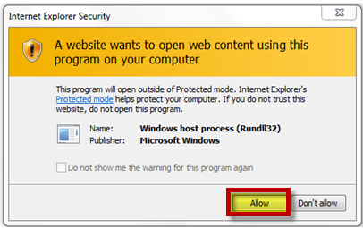
- The Remote Access page appears with links to access Abt's web applications, including: Oracle, Outlook Web Access and AGI. | 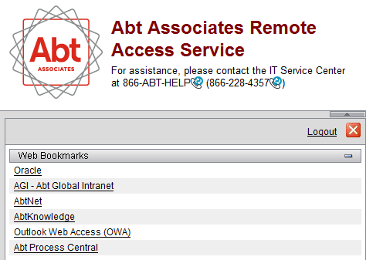
Note: If you launch Oracle from the Remote Access web page, you may receive a prompt asking you to allow changes to your computer; Please allow. You may also see a prompt to allow data to pass through remote.abtassoc.com; Click Yes.

Accessing Oracle

Oracle is Abt’s financial management system. You will use Oracle to complete your weekly timecard.
- Click on the Oracle link (a new window will pop up). |  | 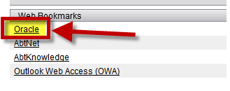
- You may be prompted to run or allow certain applications. Click Allow or Run.

- Enter your username and password again.  Click Log In. | 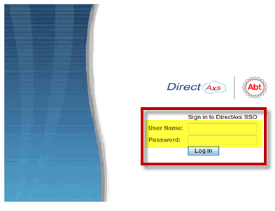

Accessing Webmail

- Launch Internet Explorer and go to http://abtremote.abtassoc.com.

- Log in with your username and newly selected password. | 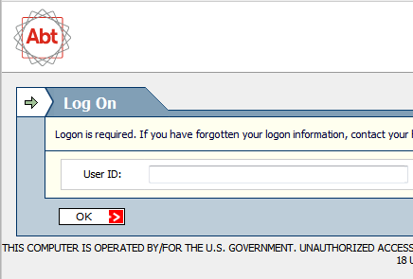
- Click on the Outlook Web Access (OWA) link. | 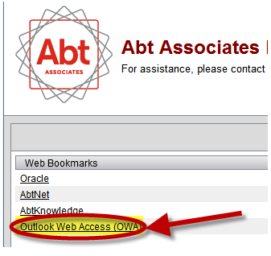
- You may be prompted to run or allow certain applications. Click Allow or Run.

- A Windows Security window will pop up.  Enter your email address in the Username field.  Same password as above.  Click OK. | 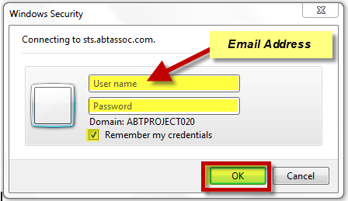
- Select your language and time zone.  Click OK. | 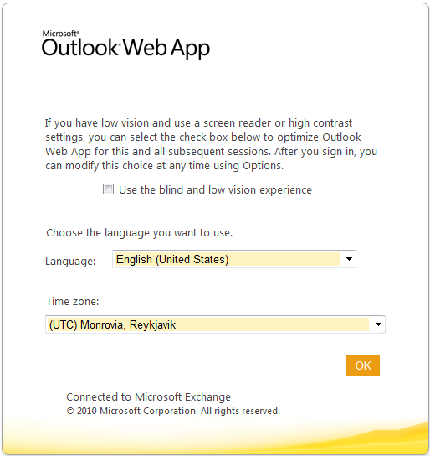

Access from your Abt Project Computer

Configuring Outlook

- Open Outlook.  Click “Next”. | 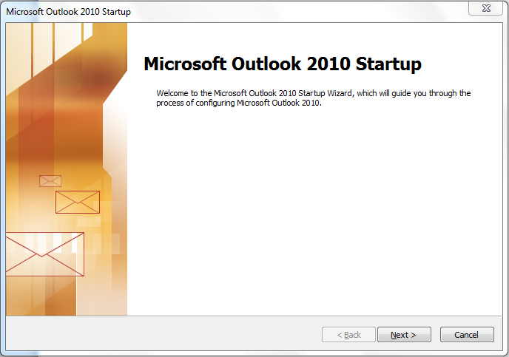
- Select “Yes” and click “Next”. | 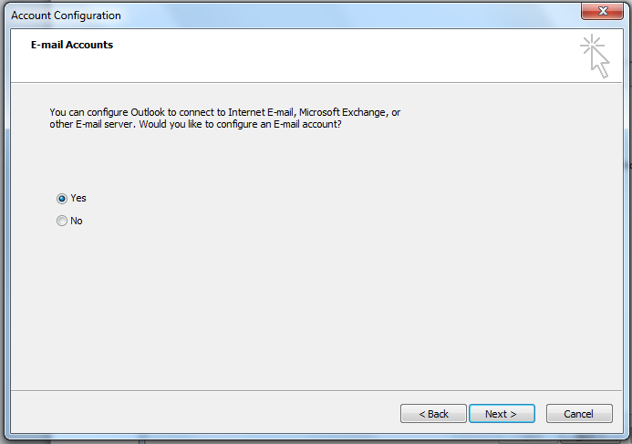
- Enter your account information.  Your password is the same one you set up for Abtremote.  Click “Next”. | 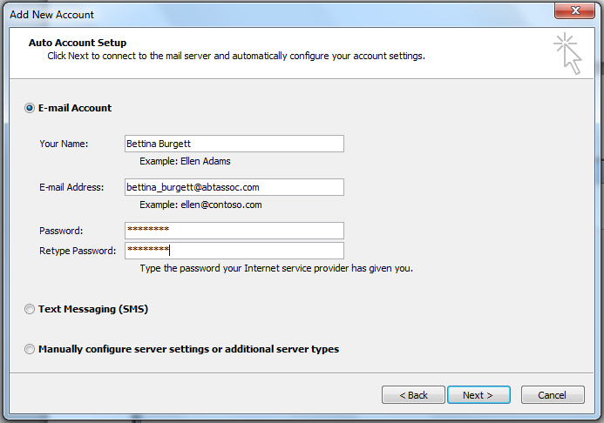
- Outlook will search for server settings. This may take a few minutes.  When it completes, click “Finish”.  Outlook will now open with your email account. | 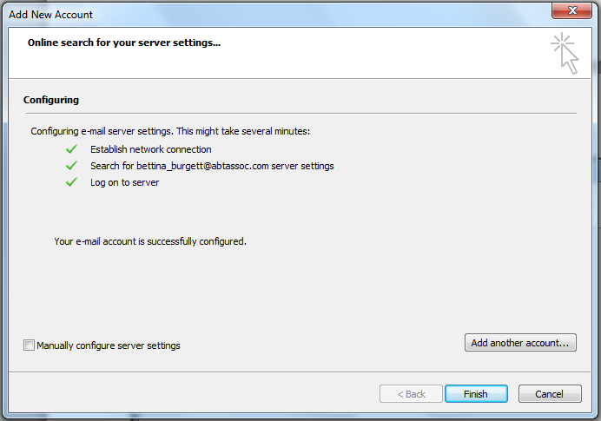

Enrolling Your Certificate
A certificate needs to be installed on your Abt computer so that you have password-less access to Abt applications.
You should have received an email from ITServiceCenterNotice with the subject line “Your Reference Number”. Your IT manager will need this number to enroll your certificate.
Once your certificate is enrolled you will see the AnyConnect icon in your system tray.
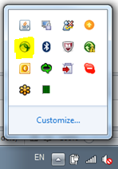
When you are in an office with a firewall (your IT manager can tell you if you are), the client will say “On a trusted network”.
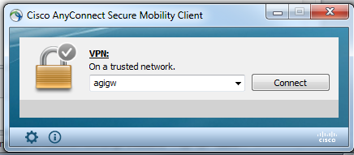
When you take your computer outside the office AnyConnect will automatically connect and say “Connected to agigw”.
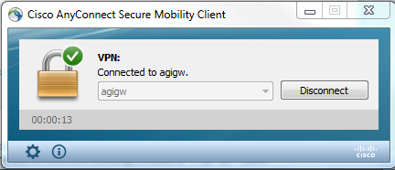
This allows you easy access to Abt applications on your Abt laptop regardless of where you are.

Accessing the Abt Global Intranet (AGI)

AGI, our new company intranet, will strengthen our ability to work together and share and maintain information. Go there to see company news, find forms and policies and look up your colleagues in the staff directory. One new key feature is “Today I Learned,” a forum for all staff to share two or three sentences on an insight or information you think your colleagues would benefit from. Think of it as a ‘virtual hallway,’ and get ready to contribute and learn something new every day.
- On your desktop you will see the AGI Icon. | 
- Double-click and it will automatically sign you in. | 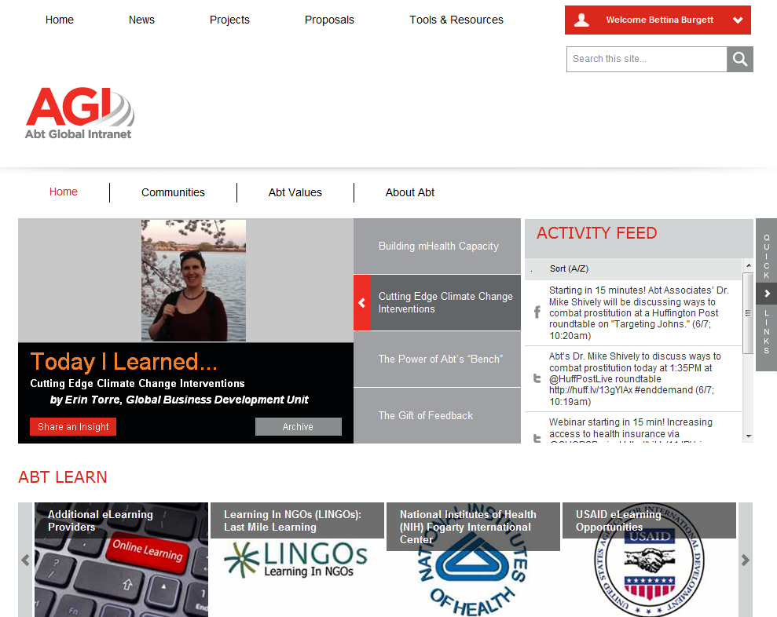

Accessing Oracle
Oracle is Abt’s financial management system. You will use Oracle to complete your weekly timecard.
- Hover your mouse over the “Quick Links” menu on the right side of your AGI page.  - Select “Oracle”. | 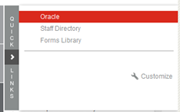
- Oracle will automatically log you in. | 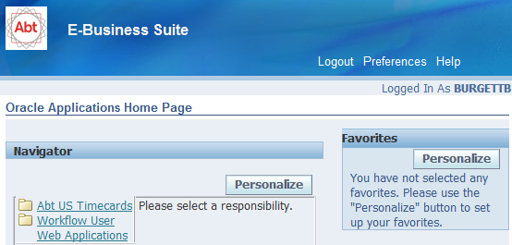

Accessing Webmail
On a rare occasion you may want to access Webmail (Outlook Web Access) on your Abt computer.
- Double-click on the AGI icon to open AGI.  - On the “Tools & Resources” tab, click on “Outlook Web Access”.  Webmail will open in your browser. | 